**Setting up Hadoop project in eclipse.**

**1. Creating a java project using the below link**

## **https://www.youtube.com/watch?v=U5yhJiFRL38**

**2.** .Add the below list of jars from the share folder (hadoop-2.10.0\share) to your build path(one project properties you will find build path option) to resolve compilation the

dependencies

Add to build path

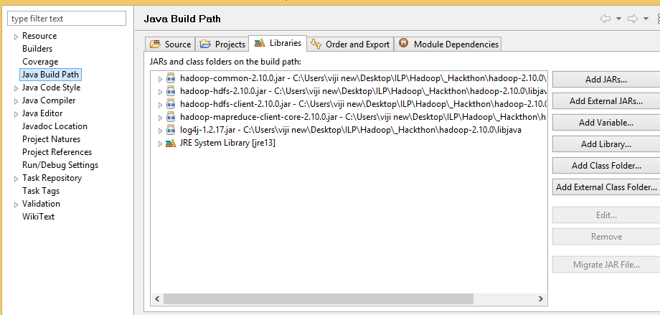

After adding the jar to the build path

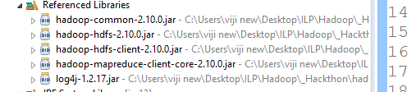

Note:

use Apache 2.10 hadoop distribution library

https://archive.apache.org/dist/hadoop/common/hadoop-2.10.0/hadoop-2.10.0.tar.gz

3. Development of MR Job

Create the driver class,mapper and reducer code using java. If there are no compilation errors, proceed with packaging

4. create the jar using the export command.

https://www.youtube.com/watch?v=jDDYSdgNf9Q

5. Execute and deployment refer

docker / cloudera Quickstart VM documentation